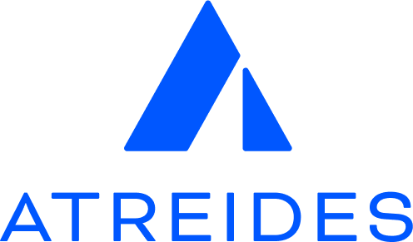

**Job Title:** Azure Infrastructure/Site Reliability Engineer (SRE) (Hybrid, UK)

**Hybrid:** Remote + 2 days a week in Cheltenham, Hereford, or Poole (employee choice)

**Clearance:** DV

JobID: 03

**Company Overview:**Atreides transforms complex multi-modal datasets into geo-spatial data subscriptions, empowering diverse industries with high-fidelity data solutions. We value diversity, inclusion, trust, and autonomy in our fast-growing, mission-driven company.

**Team Overview:**We are a passionate team of engineers, data scientists, and analysts with backgrounds in operational intelligence, law enforcement, large multinationals, and cybersecurity operations. We obsess about designing products that will change the way global companies, governments, and nonprofits protect themselves from external threats and global adversaries.

**Position Overview:**We seek an Azure Infrastructure/SRE with a focus on Infrastructure as Code (IaC). You'll design, implement, and maintain scalable, secure Azure infrastructure, ensuring reliability for large-scale data processing. Collaborate with our developers to provide a robust platform for our applications.

**Team Principles:**At Atreides, we believe that teams work best when they:

* Remain curious and passionate in all aspects of our work
* Promote clear, direct, and transparent communication
* Embrace the 'measure twice, cut once' philosophy
* Value and encourage diverse ideas and technologies
* Lead with empathy in all interactions

**Responsibilities:**

* Design, implement, and maintain Azure infrastructure using IaC.
* Optimize infrastructure for performance and cost-effectiveness.
* Ensure system security and compliance.
* Collaborate with developers to support application needs.
* Troubleshoot and resolve infrastructure issues.
* Document infrastructure design and specifications.
* Work with third-party vendors on defense-facing programs.

**Qualifications:**

* 3+ years in Azure Infrastructure/SRE roles; certifications are a plus.
* Experience with IaC tools and container orchestration.
* Knowledge of VPN solutions, big data environments, SQL/NoSQL databases.
* Familiarity with geospatial data formats is a plus.
* Experience with DevOps tools and networking concepts.
* Strong problem-solving and communication skills.

**Compensation and Benefits:**

* Competitive salary
* Comprehensive health, dental, and vision insurance
* Flexible hybrid work environment
* Flexible hours, work travel opportunities, competitive vacation, and parental leave

If you're passionate, curious, and ready to innovate with large-scale data, we'd love to hear from you.